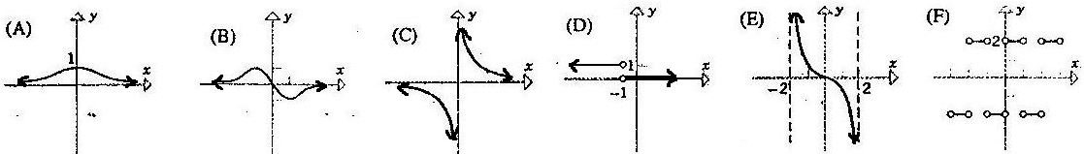
_____
Concept 3.1
Calculate the derivatives of the functions and fully simplify your solutions.
$f(x)=6x^{\frac{5}{2}}−\sqrt[4]{x^{3}}+\frac{2}{x^{3}}+1$ $f(x)=(x^{2}−7x−3)(x^{3}−4x)$ $f(x)=\frac{2x−5}{3x^{2}−x}$

$f'(x)=$_______________________ $f'(x)=$______________________ $f'(x)=$______________________

Concept 3.2
Calculate the derivatives of the functions without simplifying your solutions at all!
$f(x)=(x^{2}−5x+2)^{3}$ $f(x)=\sqrt[5]{x^{2}−1}$ $f(x)=\frac{(x^{2}+x)^{3}}{4x−1}$

$f'(x)=$_______________________ $f'(x)=$_______________________ $f'(x)=$_______________________

Concept 3.3
Determine whether the function is continuous and or differentiable at the given point. Circle your solutions.

$f(x)=\left\{\begin{matrix}x^{2}+2,x<0 \\ 2, x≥0\end{matrix}\right.$ $x=0$ $g(x)=\left\{\begin{matrix}(x^{2}−1)^{2},x≤−1 \\ 6x+6, x>−1\end{matrix}\right.$ $x=−1$ $h(x)=\left\{\begin{matrix}\sqrt{x+7}, x<2 \\ x^{2}−5, x≥2\end{matrix}\right.$ $x=2$

Cont: Yes No Diff: Yes No Cont: Yes No Diff: Yes No Cont: Yes No Diff: Yes No

Concept 3.4
Match the graph of the function with the graph of its derivative. Write your solution (A-F) on the line.

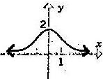

Determine which graph represents the function and which graph represents the derivative. Circle your solutions.

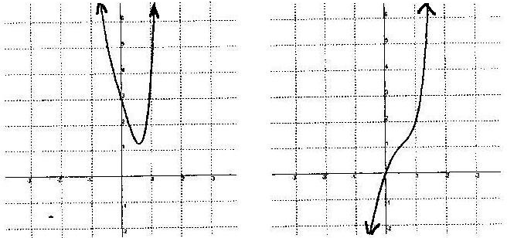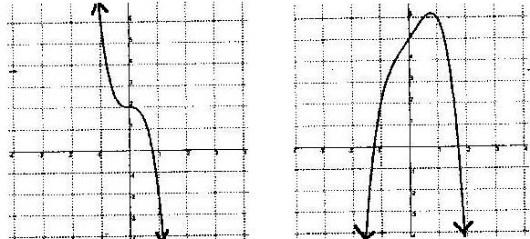

Function $f(x)$ Function $f(x)$ Function $f(x)$ Function $f(x)$

Derivative $f'(x)$ Derivative $f'(x)$ Derivative $f'(x)$ Derivative $f'(x)$

BOTH BOTH

Concept 3.5
Calculate the slope of the tangent to $f(x)=−3x^{2}+2x+5$ at the point (4, -35). _____________

Find all x-values for which $f(x)=2x^{2}+\text{12}x−6$ has a horizontal tangent line. _____________

Write the equation of the tangent line to the graph of $f(x)=3x^{3}+x$ at the point x = -1. _____________

